PREDICTION OF DISTRIBUTION PATTERN OF AEDES AEGYPTI AS DHF MAIN VECTOR
IN JEMBER

Yudha Nurdian¹, Asmoro Lelono²
¹Department of Parasitology, Faculty of Medicine, University of Jember, Jember
²Department of Biology, Faculty of Mathematics and Natural Sciences, University of Jember, Jember

ABSTRACT

The research has been held in the aim to know the Pattern prediction of Aedes aegypti as main vector of DHF in Jember, East Java Indonesia. It covered of the number of incidence and cluster of case in the peak of DHF epidemic in rainy season. The data were collected from November 1st 2005 until February 28th 2006 and November 1st until February 28th 2007. The results show that between two peak season there were 433 cases of DHF in 2005-2006 and 66 case in 2006-2007. Based on the prediction of vector distribution there were six large and four small groups in the year of 2005-2006 compared with one large and one small group in the year of 2006-2007. Most of the vector habitat close related with human settlement and the climate perhaps plays the main role in outbreak of Ae. aegypti population. The lows incidence in the year of 2006-2007 perhaps because of the implementation of control methods drive by official government of Jember Residence call “jum’at bersih” or clean Friday with participating of community to eradicate Ae. aegypti potential habitat around the environment.

Keywords : prediction, distribution, DHF, vector

Correspondence: Yudha Nurdian, Department of Parasitology, Faculty of Medicine, University of Jember,
Jl. Kalimantan 37, Jember, East Java, Indonesia

INTRODUCTION

Dengue fever (DF) and dengue hemorrhagic fever (DHF) are diseases that have long been endemic in tropical and sub-tropical regions of the world. Epidemic DHF emerged in Southeast Asia following World War II. The first recorded DHF epidemic in this area occurred in Manila, the Philippines, in 1953-1954, followed by another in 1956. Fourteen years after the 1953-1954 Philippines epidemics, DHF epidemics were reported in the Indonesian cities of Surabaya and Jakarta. Since then, outbreak of the disease have spread to involve most of the major urban area in Indonesia as well as some of the rural areas of the country (Guzman et al. 2002; Porter et al. 2005).

The disease affects hundreds of millions of people every year. Dengue virus is transmitted by the mosquito Aedes aegypti adapted to living near areas of human habitation. Dengue transmission occurs throughout the year in endemic tropical area, but there exists a distinct cyclical pattern associated with the rainy season. In tropical and sub-tropical regions, temperature and rainfall levels enable adult vectors to remain active throughout the year. This contributes to a continuous transmission cycle that makes the disease endemic (Porter et al. 2005; Sujariyakul et al. 2005).

Indonesia is an archipelago located at 95º to 141º east longitude and 6º north to 11º south latitude and consisting of more than 17000 islands of various sizes, of which 6000 are inhabited. Administratively, the country is divided into 33 provinces and 315 districts (regencies). Being located at the equator, all areas have tropical climate (Kusriati & Sutomo, 2005). DHF is endemic throughout the country and is currently endemic in more than 300 regencies. Ae. aegypti is the principal vector species and breed extensively in all the islands. A mosquito larval survey carried out between 1992-1996 showed an average house index (HI) of 20% in seven cities. All the four serotypes (DENV-1 to 4) are endemic in most of the large cities of the country. The prominent virus serotype varies from year to year (Porter et al. 2005; Umniyati 2000).

East Java is one of three areas in Indonesia where the incidence of DHF is higher after Jakarta and West Java. Jember is one of the regencies in East Java where incidence of DHF is quite regular every year and some districts have become endemic. Jember regency consists of 31 districts and 3 of them located at Jember town are Kaliwates, Patrang and Sumbersari. The outbreak of DHF occurred in rainy season between 2005-2006. In this study we will predict the distribution of Ae. aegypti as a main vector of DHF in Jember.

MATERIALS AND METHODS

Jember is a regency consisted of 31 districts and located at 113º30’ -113º45’ east longitude and 8º00’ – 8º30’ south latitude. The town of Jember consists three districts of Patrang, Kaliwates and Sumbersari. It is bordered by Arjasa in the north, Pakusari in the east, Jenggawah in the south and Sukorambi in the west. There are many new human settlements, public service areas, economic, education, industrial and also business activity. Those three districts have become endemic base the record of DHF incident constatly every year.

Studies of the dispersal of Ae. aegypti show that the females mosquito generally fly 100 – 500 m. This range is short compared to other mosquitoes, such as Ae. taehiorhynchus (Wiedemann) which disperse up to 10 km. Some authors believe that Ae. aegypti fly only a short distance from their emergence site (Honorio et al., 2003). However a study conducted in urban San Juan, Puerto Rico showed that female Ae aegypti could, in a few days, travel at lest 441 m from a releasing point (Reiter et al., 1995). Recapture studies of marked female Ae. albopictus (Skuse) another potential dengue vector, showed a maximum dispersal of 400 – 600 m. This same species flew no more than 200 m in studies in Hawaii and Japan. Based on those information we plotted the location of DHF patient and make a circle around it for about 200 m to predict the area consist of Ae. aegypti. Every patient recorded has own circle in map, from this data we try to predict the distribution pattern of Ae. aegypti in all of the areas.

RESULTS

Figure 1. The differences of prevalence between peak season in 2005/2006 and 2006/2007 obtain from epidemic DHF in Jember town East Java Indonesia

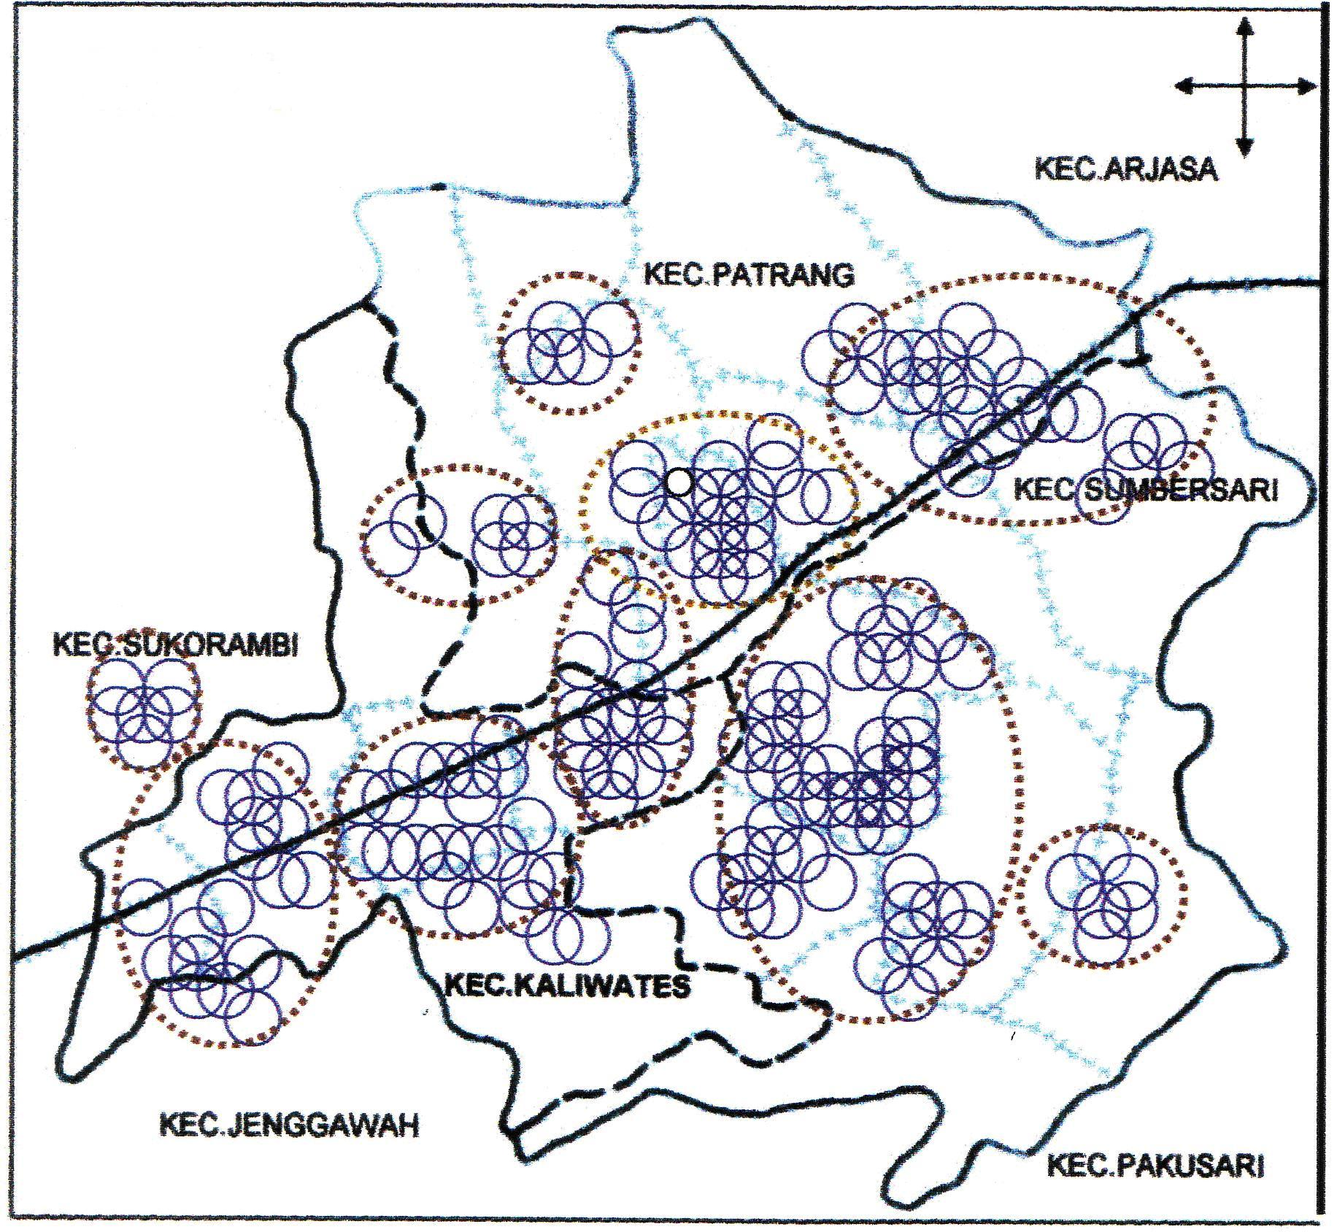

Figure 2. Principal feature of Jember town, the prospectuses of Distribution Pattern from Aedes aegypti as DHF in Jember residence East Java, Indonesia, from November 2005 to February 2006

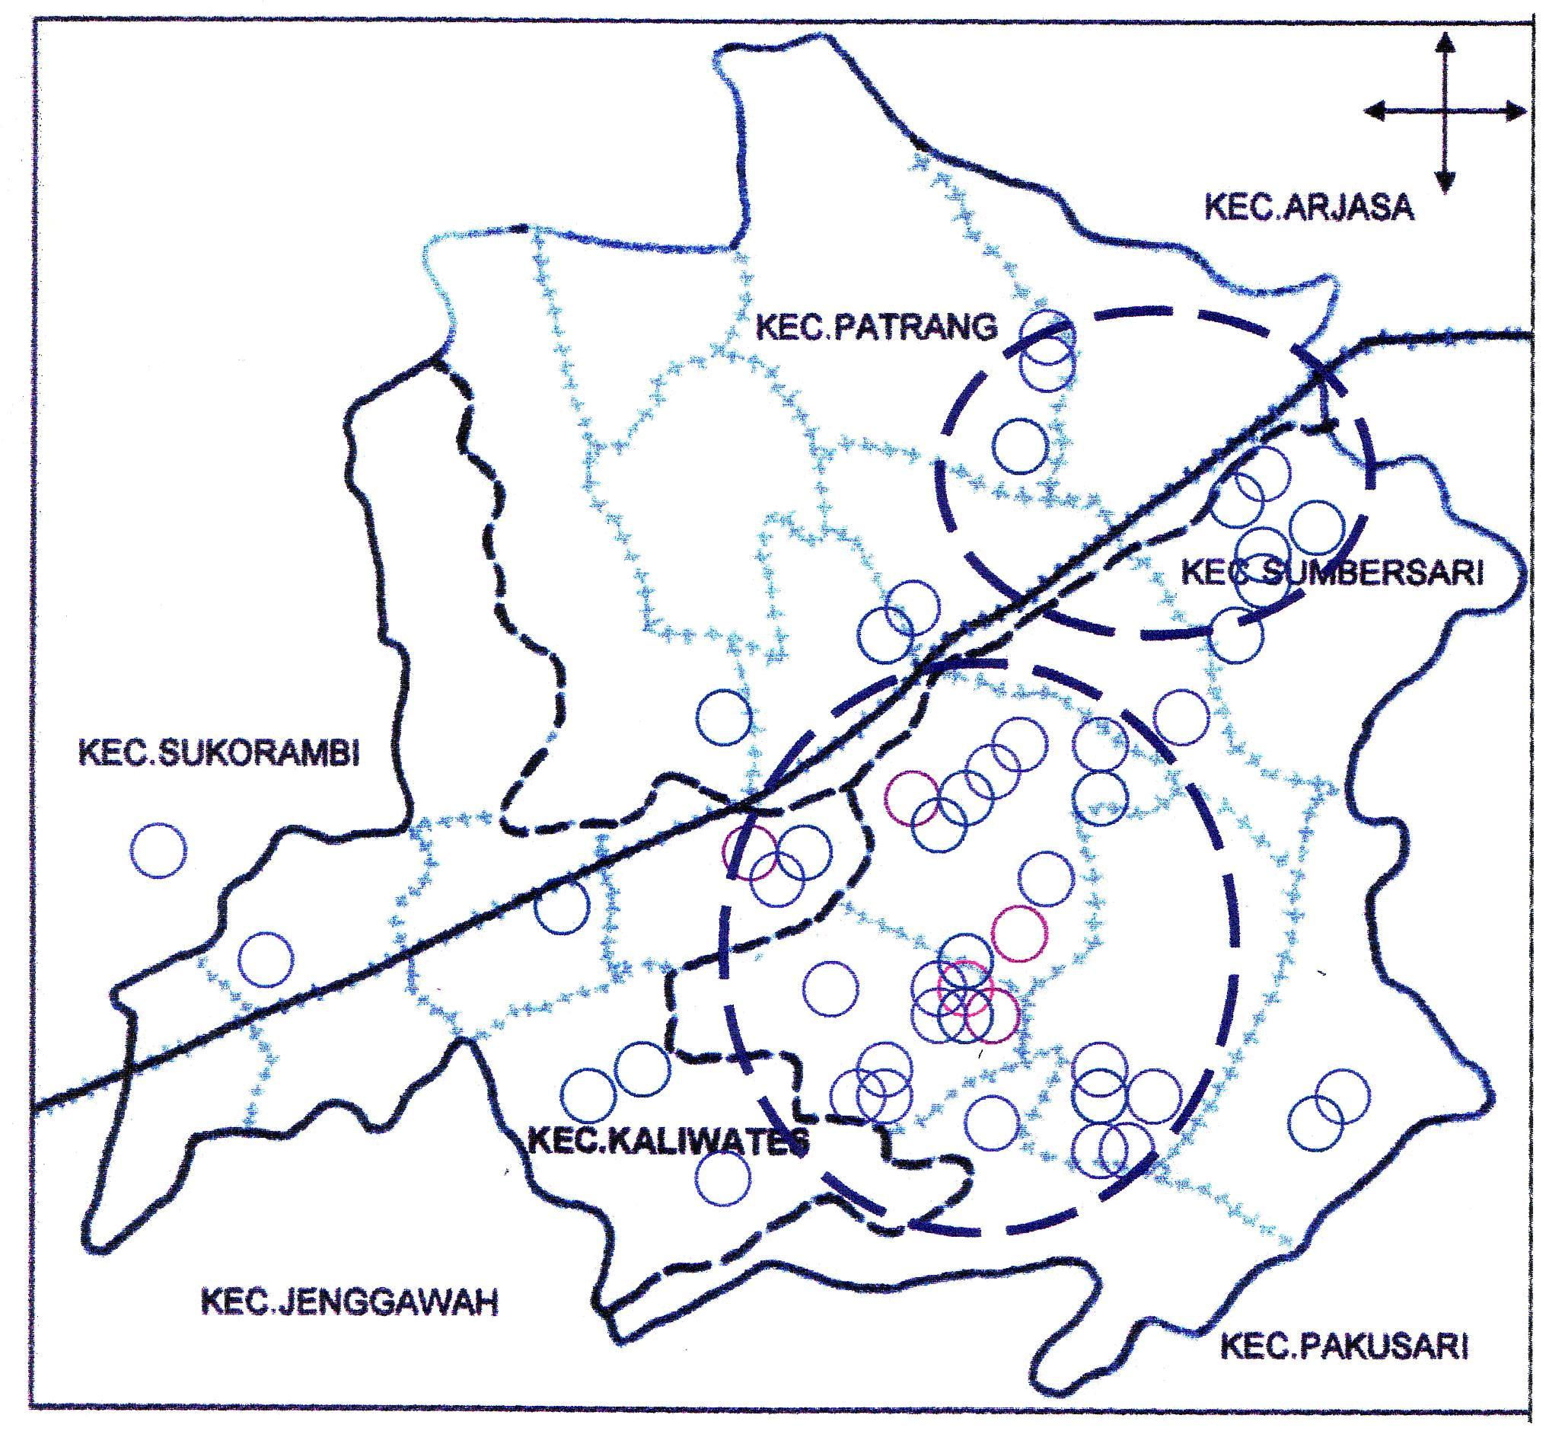

Figure 3. Principal feature of Jember town, the prospectuses of Distribution Pattern from Aedes aegypti as DHF in Jember residence East Java, Indonesia, from November 2006 to February 2007

DISCUSSION

Rainy season between 2005-2006 was the outbreak incidence of DHF in Jember. There were 433 cases in four month between November 2005 and February 2006. The opposite condition occurred in rainy season between 2006-2007 with 66 cases (Figure 1). The outbreak in the rainy season was influenced by the condition of climate. In Indonesia dengue is predominantly endemic in urban areas where more than 35% of the country’s population live (Kusriastuti & Sutomo 2005; Umniyati & Sumarni 2000). Rapid industrial and economic development over the past two decades has brought about massive infrastructural development, both in housing and commercial sectors. Large-scale rural-urban migration has created slum settlements where inadequate water and sanitation facilities and poor solid-waste management have resulted in the creation of breeding sites for Ae. aegypti. Tropical rainfall provides additional Aedes breeding sites and favorable temperature and humidity results in the rise of dengue transmission (Sujariyakul et al., 2005).

The principle breeding sites of Aedes mosquitoes include containers, such as cans, pots, earthen jars, plant pot bases, and drums, as well as tires and tree holes. Breeding sites of Aedes mosquitoes vary spatially. Information is particularly valuable if it can be linked with dengue incidence, since both the mosquitoes and their breeding sites require interventions to minimize transmission. Dengue is transmitted to humans. The only known reservoir of the disease is by Aedes mosquitoes. Adult female Aedes mosquitoes acquire the dengue virus by biting an infected human during the viremic phase, which usually last for 4-5 days, but may last up to 12 days (Chaeronssok et al. 1999; Graham et al. 1999; Honorio et al. 2003).

The prediction of distribution pattern of Ae. aegypti in rainy season between 2005 and 2006 consists of sixth large group and four small groups. During this outbreak incidence almost all of human settlements reported the DHF cases (Figure 2). This condition could be influenced by environmental factors, such as climate and also sanitary procedure in the human settlement such as discarded container around the house. Discarded containers in a house might play a role as potential breeding sites (Kongsomboon et al. 2004; Sujarijayakul et al. 2005). A previous study reported that discarded containers contained plenty of organic matter and subsequently tended to produce large adult Aedes mosquitoes which had faster development and better survival. Studies in Taiwan, Puerto Rico and Australia confirmed that the presence of discarded items was associated with outbreak occurrence. In addition, according to the bionomics of Aedes mosquito, dispersal is usually confined to the area around potential breeding sites. After laying eggs, the female mosquito would take blood meal for the next gonotrophic cycle in that area. Thus, all of family members who live in houses that house container have a high risk of being bitten by mosquitoes (Igarashi, 1997; Wishman et al., 2004; Prompou et al., 2005).

The transmission of dengue viruses is climatic sensitive for several reasons. First, temperature changes affect vector-borne decease transmission and epidemic potential by altering the vector’s reproductive rate, biting rate, the extrinsic incubation period of the pathogen, by shifting a vector geographical range of distribution and increasing or decreasing vector-pathogen-host interaction and thereby affecting host susceptibility (Lee & Rohani 2005). Second, precipitation affects adult female mosquito density. An increase in the amount of rainfall leads to an increase in available breeding sites which, in turn, leads to an increase in the number of mosquitoes. An increase in the number of adult female mosquitoes increases the odds of a mosquito obtaining a pathogen and transmitting it to a second sensitive host (Gubler, 1989; Prompou et al., 2005). Third, a distinct seasonal pattern in DHF outbreaks is evident in most places. In tropical regions, where monsoon weather pattern predominate, DHF hospitalization rate increase during the rainy season and decrease several month after the cessation of the rain. This decline may be related to a decrease in mosquito biting activity, decrease in longevity of female mosquitoes, or both.

The opposite condition occurred in the rainy season between 2006 and 2007, which consisted of one large group and one small group (Figure 3). This condition could be influenced by environmental factors such as climate and control programmed of nesting site call with participating of community to eradicate Ae. aegypti potential habitat in the human settlement. Since November 2006, considering the constraints of outbreak of DHF so the government of Jember Residence, trough the Bureaus of Health, organized community efforts were conducted at village level through “Jum’at Bersih” or clean Friday. This program includes the official government, PKK (Women Empowerment Welfare Group) or Dasa Wisma and also the community. This program has three components: (i) Health education using mass media, women’s groups and schoolchildren; (ii) door-to-door visit by PKK volunteer and jumantik (juru pemantau jentik) for implementing the 3M program, i.e. (a) covering water containers (Menutup); (b) cleaning water containers (Menguras), and (c) burying discarded containers (Mengubur); and (iii) source reduction using community participation and intersectoral coordination.

The target group of the program includes individuals, families and community at large who are living in urban endemic areas to involve them in source reduction practices. Each individual and family should not only be aware of the importance of source reduction but should also keep the environment clean. It is expected that their housing environment, both indoors and outdoors, will be free of larval Ae. aegypti breeding habitats.

CONCLUSION

For the future the official government must program consistent efforts to develop healthy physical environment. It is necessary to control dengue transmission by the participation of the community. Good quality of healthy environment can reduce the incidence of DHF through elimination of breeding sites. Orientation, advocacy and other health education campaigns to related sectors need to be conducted regularly and aggressively. Although these policies have been built up at the level of decision-makers, it has not yet percolated to the ground level. There is a need to make them operational at the field level.

ACKNOWLEDGMENTS

We gratefully thank to Drs. Sugeng Catur Wibowo as staff of the Health Bureau of Jember Regency for his data contribution and constructive discussion. We also thanks to all participants for supporting team since the process of the research until the making of this report.

REFERENCES

Graham, RR, Juffrie, M, Tan, R, Hayes, CG, Laksono, I, Ma’roef, C, Erlin, Sutaryo, Porter, KR, Halstead, SB, 1999, ‘A prospective seroepidemiologic study on dengue in children four to nine years of age in Yogyakarta, Indonesia I. Studies in 1995–1996’, Am J Trop Med Hyg, vol. 61, no. 3, pp. 412-419.
Gubler, DJ 1989, ‘Active surveillance for dengue and dengue hemorrhagic fever’, Biol Oficina Sanit Panam, vol. 107, no. 1, pp. 22-30.
Guzman, MG, Kouri, G, Bravo, J, Valdes, L, Vazquez, S, Halstead, SB 2002, ‘Effect of age on outcome of secondary dengue 2 infection’, Int J Infect Dis, vol. 6, no. 2, pp. 118-124.
Honorio, NA, Silva, WC, Leite, PJ, Goncalves, JM, Lounibos, LP, Oliveira, RL 2003, ‘Dispersal of Aedes aegypti and Aedes asbopictus (Diptera: Culicidae) in an urban endemic dengue area in the state of Rio de Janeiro, Brazile’, Mem Inst Oswaldo Cruz, vol. 98, no. 2, pp. 191-198.
Igarashi, A 1997, ‘Impact of dengue virus infection and its control’, FEMS Immunol Med Microbiol, vol. 18, no. 4, pp. 291-300.
Kongsomboon, K, Singhasivanon, P, Kaewkungwai, Nimmannitya, S, Mammen, MP, Nisalak, A, Sawanpanyalert, P 2004, ‘Temporal trends of dengue fever/dengue hemorrhagic fever in Bangkok, Thailand from 1981 to 2000; an age period – cohort analysis’, Southeast Asian J Trop Med Public Health, vol. 35, no. 4, pp. 913-917.
Kusriastuti, R & Sutomo, S 2005, ‘Evolution of dengue prevention and control program in Indonesia’, Dengue bulletin, vol. 20, pp. 1-7.
Lee, HL & Rohani, A 2005, ‘Transovarial transmission of dengue virus in Aedes aegypti and Aedes albopictus in relation to dengue outbreak in an urban area in Malaysia’, Dengue Bulletin, vol. 29, pp. 106-111.
Prompou, S, Jaroensutasinee, M, Jaroensutasinee, K, 2005, ‘Climatic factors affecting dengue hemorrhagic fever incidence in southern Thailand’, Dengue Bulletin, vol. 29, pp. 41-48.
Porter, KR, Charmagne, G, Beckett, Kosasih, H, Irsianatan, R, Alisjahbana, B, Rudiman, PIF, Widjaja, S, Listiyaningsih, E, Ma’roef, CN, McArdle, JL, Parwati, I, Sudjana, P, Jusuf, H, Yuwono, D, Wuryadi, S 2005, ‘Epidemiology of dengue and dengue hemorrhagic fever in a cohort of adults living in Bandung, West Java, Indonesia’, Am J Trop Med Hyg, vol. 72, no. 1, pp. 60-66.
Reiter, P, Amador, MA, Anderson, RA, Clark, GG, 1995, ‘Short report: Dispersal of Aedes aegypti in a urban area after blood feeding as demonstrated by rubidium-marked eggs’, Am J Trop Med Hyg, vol. 52, pp. 177-179.
Sujariyakul, A, Prateepko, S, Chongsuvivatwong, V, Thammapalo, S 2005, ‘Transmission of Dengue Hemorrhagic Fever: At home of School?’, Dengue Bulletin, vol. 29, pp. 32-40.
Umniyati, SR, Sumarni, Umayah 2000, ‘Evaluation of Community-base Aedes control programme by Source Reduction in Perumnas Condong Catur, Yogyakarta, Indonesia’, Dengue Bulletin, vol. 24.
Wichman, O, Hongsiriwon, S, Bowonwatanuwong, C, Chotivanich, K, Sukthana, Y, Pukrittayakamee, S 2004, ‘Risk factors and clinical features associated with severe dengue infection in adults and children during the 2001 epidemic in Chonburi, Thailand’, Journal Tropical Medicine and International Health, vol. 9, no. 9, pp. 1022-1029.

